Author’s Response: npj-computational-materials
fa767f01-1b6f-44b8-ad70-21eda9804daf by Heilman, et al.

We thank the referees for their positive and constructive comments and suggestions. We have addressed all the comments in point-by-point detail in the revised manuscript as described below. Comments of the referees are reproduced in black italic typeface, while our responses are in regular black typeface. A list of major changes in both the main text and Supplementary Information (SI) is given below.

Summary of Major Changes:
1. Figure 3 has been expanded to show how the message passing framework may be adapted to hyperedges of variable size in terms of number of nodes.

2. Hyperparameters have now been tabulated in Supplementary Section S3.

3. Supplementary Section S7 has been added. This section gives a case study on the difference in node representation between analogous atoms in two compositionally similar but structurally distinct materials.

4. All results reporting performance for motif-based models have been rerun with only continuous symmetry measure features after an ablation study suggested (scalar) local structure order parameters are redundant or undesirable as motif hyperedge features. This ablation study is detailed in Supplementary Section S8.

5. All results now align perfectly with the prefixed MatBench fold indices (for materials) and datasets. Performance on each of these folds is now tabulated in Supplementary Section S9. Standard deviation for performance across folds is also tabulated therein. Additionally, we plan to publish these results for the best performing bond-and-motif models on the leaderboard, allowing for global benchmark comparison against other state-of-the-art models recorded on the MatBench leaderboard.

6. Supplementary Section S6 has been added. This section gives a case study on the scaling of the number of messages contributed by each hyperedge type for increasing size of supercell. This demonstrates explicitly the improved message scaling performance of motifs over triplets.

7. The performance of all models has been further improved by amending the workflow, such that an additional validation set (in addition to a train and test set) is withheld from the matbench training sets of each fold; the model with the best performance on the withheld validation set is then used to predict targets for the test sets.

Report for Referee 1:

General Comment. The authors present a generic hypergraph convolutional network scheme for modelling crystals. They motivate the desire for hypergraphs in convolutional networks with their ability to encode structural information that would be indistinguishable in a purely edge encoding graph convolutional network. Neighboring atoms are encoded into triplet hyperedges using a Gaussian expansion-type basis and into motifs using Zimmerman’s local structure order parameters. They present their neighborhood aggregation scheme as a better scaling alternative to total exchange message passing while still encoding the hyperedges that would be missed in relatives graphs. They benchmark their graph convolutional model without hyperedges, with triplets, and with motifs using datasets from MatBench and Materials Project.

General Response. We would first like to thank the reviewer for their thorough overview of the work and their time spent in reviewing it. In response to these comments, we now have an extended discussion on motivation that draws on other approaches, such as atomic cluster expansions and more specifically, the truncation of terms at a certain order in expansions (such as in multipole expansions). To clarify some ambiguous presentation in the original draft, we’ve now included a statement of the specific aggregation functions used in the main text, and incorporated figure 2 into a larger figure that aims to show how neighborhood aggregation is used in the generalized message passing framework. Furthermore, hyperparameters were tabulated in the SI. And, a new supplementary section was added to help demonstrate the effectiveness of motif-based models in distinguishing compositionally similar but structurally distinct materials.

Comments from Referee 1:

Comment 1. The introduction references lattice-based cluster expansion methods and their use of n-body clusters being analogous to hyperedges. If there is room for it, it would be good to mention that generalizing lattice-based cluster expansions was the original inspiration for the development used atomic cluster expansion (ACE) basis/descriptors that have been very successful in machine learned-interatomic potentials (MLIPs).

Response 1. Indeed, lattice-based cluster expansions and particularly, atomic cluster expansions, do help provide some more rigorous motivation. As such, a short discussion of atomic cluster expansion approaches was added in the introduction (with citations) to further highlight the importance of higher-order descriptors in material systems.

We have now added the related discussion on Page 1 in the introduction of the main text:
“”
… these allow for the learning of a certain type of `cluster-correlation expansion' (CCE) [citations] by the model, where clusters of interest correspond to the hyperedges defined. Indeed, atomic cluster expansions have previously been utilized, to great effect, in the generation and application of transferable interatomic potentials [citations] and are also motivated by lattice-based cluster expansion methods.
“”

Comment 2. CSM and LSOP need to be defined in Figure 2.

Response 2. Definitions for RBF, CSM, and LSOP were added in the figure caption.

Comment 3. In cluster expansions, it’s very common to restrict the clusters above order 3 (quadruplets, quintuplets, …) to short ranges because their effective cluster interaction parameters decay quickly beyond the first neighbor shell. Likewise, in multipole expansions, the higher order multipole fields decay increasingly faster with distance. Some version of this ‘higher order interactions have shorter ranges’ argument would add justification and physical intuition to the use of neighborhood aggregation.

Response 3: We thank the referee for pointing out the connection between the hyperedges discussed in this work and other common expansion techniques. Such motivations may certainly also be applied in this case to the disregard of even higher-order hyperedges (i.e. second shells, etc.). In response, a paragraph was added to the introduction using such rationale to further motivate the use of neighborhood aggregation and local atomic environments. This serves as justification for the truncation of hyperedge types beyond first shells/motifs/local coordination environments.

We have now added the related discussion on Page 1-2 in the introduction of the main text:
“”
In many-body expansions, such as CCE, expansions are often truncated to exclude higher-order terms since their associated parameters are typically observed to decay quickly with increasing distance from the central atom. Similarly, in multi-pole expansions, higher-order terms (such as quadrupole, octupole, and beyond) often contribute considerably less to long-range field effects. The intuition gained from these considerations further support the use of only a localized set of descriptors for atom-centric models. This intuition is used in the present work to motivate the use of neighborhood aggregation for hyperedge message passing, wherein only atomic features local to hyperedges are incorporated in their associated messages.

“”

Comment 4. The neighborhood aggregation needs to be more fully or explicitly described in general.

Response 4. We thank the referee for pointing this out and we agree that more clarification about the neighborhood aggregation is helpful for reader comprehension. To more fully describe the approach taken in this work, the neighborhood aggregation section was expanded with more narrative explanation of the method in general. An explicit statement of the form of aggregation function used in this work was further transferred from supplementary note S2 to the model architecture section of the main text.

In response to this point, the following comments were added in the main text:

On pg. 7 of the Neighborhood Aggregation section:
“”
… we may form a single `neighborhood feature' representative of all contained nodes of a hyperedge by way of an aggregation function. This aggregation function takes as input a variable number of node features and returns a single feature of fixed dimension.
“”

And, on pg. 7 of the Model Architecture section:
“”
… the AGG function chosen for neighborhood aggregation through message passing on hyperedges was a combined set of component-wise maximum, minimum, average, and standard deviation, all with learnable attention weights.
“”

Comment 5. The schematic in Figure 3 is unclear. Can the message passing be broken into sequential steps for more clarity?

Response 5. Figure 3 has been expanded to show how the different message passing approaches can be adapted to variably-sized hyperedges. Additionally, definitions for all relevant functions in message passing have been defined graphically therein.

The revised Figure 3 is shown below:
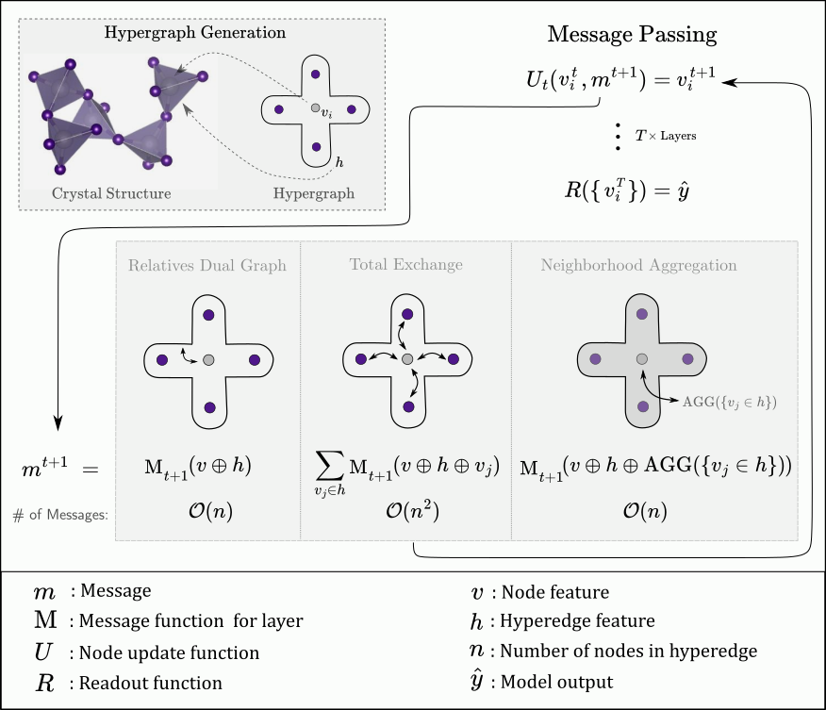

Comment 6. Despite using the same hyperparameters for CGCNN and CGConv as in the reference, it would be helpful if they were tabulated in the SI.

Response 6. Hyperparameters (including: node hidden feature dimensionality; crystal hidden feature dimensionality, equivalently final linear layer width; number of convolutional layers) are presented in S3. A table summarizing these was further added to S3.

Comment 7. Some specific benchmarks that could be constructed for the three models should be included. For example, if the square anti-prism vs. cubic environment was used as benchmark, twisting between C1 and C2 local environments could provide a more tangible demonstration of the benefits.

Response 7. We agree with the referee that it is helpful to include specific benchmarks to demonstrate the capability of three models in distinguishing local atomic environment. Here, we choose analogous node representations for two different phases of the transition metal dichalcogenide MoS2 (trigonal (T) and hexagonal (H)) as a benchmark. Specifically, the normalized dot product of central molybdenum node representations from each are taken and subtracted from 1 to show relative differences for different numbers of bond and motif layers. In this way, it is demonstrated that motif layers are more effective in distinguishing the two (since they have greater calculated differences in general). However, it should be noted that this metric is somewhat ambiguous since the training target (here band gap) and training steps (here 300 epochs) greatly influences the update functions parameters. Furthermore, the RBF dimension (here 40) for the bond features greatly influences the ability of the bond-based models to distinguish small differences in bond-length.

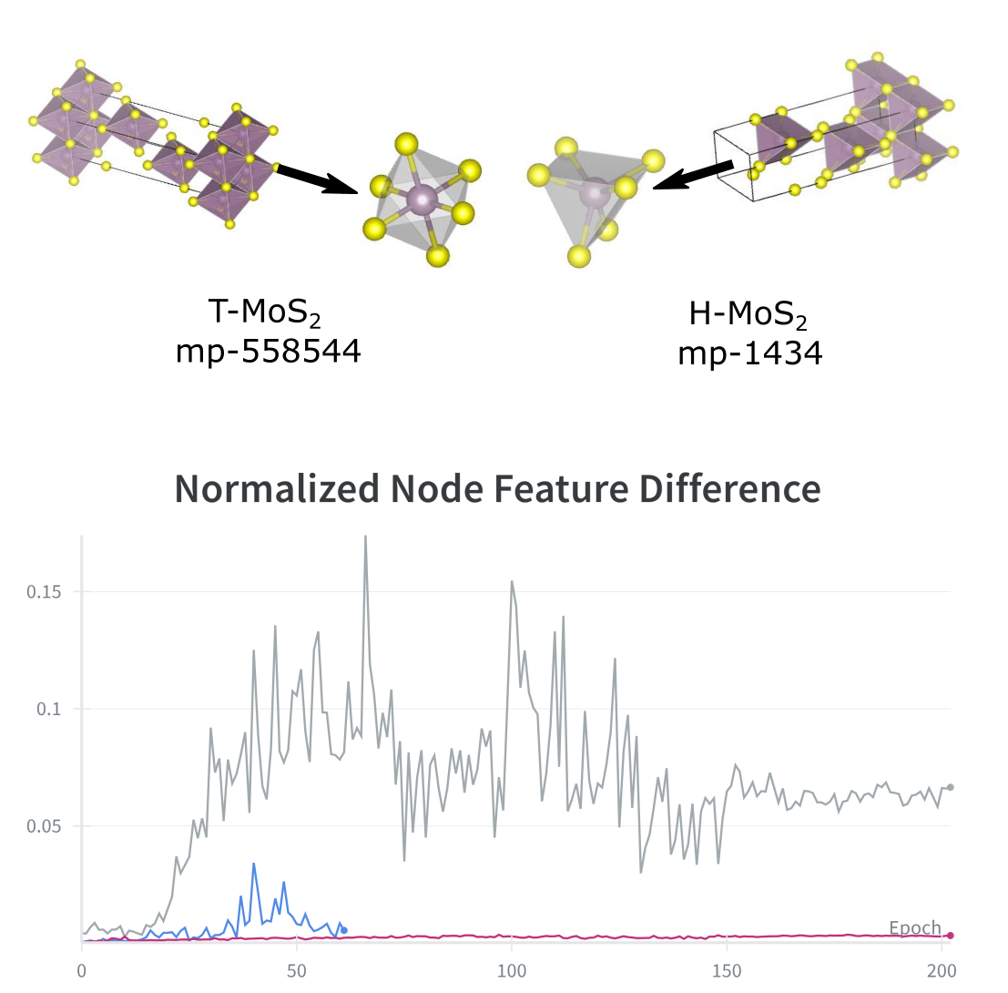

A section S7 has been added to the supplementary information that demonstrates this potentiality of motif-level hyperedges to more effectively discriminate between compositionally-similar but structurally unique material systems.

Comment 8. Why were the highest phonon modes chosen as a test? The lowest phonon modes are related to crystal stability and ferroelectric modes, especially in perovskites. This would seem to be a more challenging test.

Response 8. In this work, we used the dataset for phonons from the MatBench set of targets (https://ml.materialsproject.org/projects/matbench_phonons). The choice of highest phonon modes is simply based on the data availability. Only the highest phonon mode data is present in the dataset. We agree with the reviewer that the lowest phonon modes are more relevant for symmetry-based functional applications and material stability analysis, but generation of a new dataset for such a target is beyond the scope of this work.

Report for Referee 2:

General Comment. In this work, the authors introduce Crystal HyperGraph Convolutional Networks (CHGCNN), a model that generalizes traditional graph representations by using hyperedges to encode higher-order atomic substructures such as triplets and motifs. The study involves two solid-state materials databases (MatBench and Materials Project) and compares the performance of different hyperedge configurations. The results highlight improved predictive accuracy when both pairwise bonds and local environment hyperedges are incorporated.

General Response. We would first like to thank the reviewer greatly for their time and constructive comments. In response, we’ve added supplementary sections that aim to directly address the remarks made below, namely: an ablation study for motif feature importance and a case study on message scaling for increasingly large super cells of a specific material. Furthermore, several citations were added and some discussions were extended. This includes discussion of and citations for approaches based on simplicial complexes and the inclusion of the previously missing version numbers of datasets. Finally, a global benchmark is now provided for the novel bond-and-motif models by way of the matbench leaderboard. It should be noted here, however, that the primary aim of the paper was to investigate the performance of different hyperedge types within the same model, so for a true comparison to other state-of-the-art models, hyperedges should be incorporated into their respective graph representation schemes. Again, we would like to thank the reviewer for their time and thoroughness.

Comments from Referee 2:

Comment 1. Since hypergraphs are used to represent higher-order structural information, I recommend that the authors provide a more rigorous definition of hypergraphs from the perspective of algebraic topology, and explicitly discuss the relationship (or differences) between hypergraphs and simplicial complexes. This would strengthen the theoretical grounding of the work.

Response 1. Indeed, hypergraphs are more general than simplicial complexes but are applied here in a similar spirit as other works focused on simplicial complex networks. A paragraph giving a more general definition of hypergraphs was added at the beginning of the “Crystal Hypergraph Construction” section. An additional sentence relating hypergraphs to topologies and simplicial complexes is contained therein, with a citation that outlines these relations more completely given for the interested reader.

The following was added in response, in the third paragraph of the introduction on pg. 1:
“”
… the set of all hypergraphs on a set of nodes is more general than, and contains all possible, topological sets and simplicial complexes on V [citations]. The method proposed here reduces the intrinsic limitations of invariant crystal graph features by allowing the explicit incorporation of higher-order geometrical information in the form of hyperedges, which can be used to directly represent these higher-order structures. Furthermore, the more general definition of hypergraphs allows for complete freedom in the choice of structures to be included, as opposed to the more rigid definition and utilization of representations in simplicial-complex networks [citations].
“”

Comment 2. A major limitation of this paper is the lack of external benchmark comparisons. The experiments focus only on different internal hypergraph configurations. Without comparing to strong existing graph-based models, it is difficult to evaluate the true performance improvement of CHGCNN.

Response 2. To respond to the reviewer’s request, we publish matbench results for the novel bond-and-motif models so that explicit comparison may now be made with other models’ performance according to the matbench dataset rankings. It should be noted that while better results from a wider range of models would certainly place the current work more neatly within the literature’s ranking of absolute performance, the primary point of the article (regarding message scaling in invariant graph models) benefits from the sole control over hyperedge types, while holding all other parameters constant. Essentially, for each other model used, an equivalent hypergraph model would need to be tailored and implemented for the comparison to be made for each.

TABLE

However, we would again like to emphasize that the hypergraph framework can in principle be incorporated into any graph-based state-of-the-art models, and that global performance evaluation of hypergraphs across all possible models and other future model development is beyond the scope of this work.

Comment 3. Material systems with large unit cells or supercells are common. The authors should discuss the efficiency and scalability of the hypergraph representation for such large systems. I suggest that the authors include a case study or practical example for discussion.

Response 3. A section S6 has been added to the supplementary information that considers the message number scaling of the three distinct types of hyperedges for increasing supercell size. There it is shown explicitly the scaling behaviour of triplets greatly exceeds that of motifs and demonstrates the advantage of our motif-based hypergraph learning framework in handling large-scale material systems.

Comment 4. Important dataset details are missing. The authors should specify the exact versions of the databases used (MatBench and Materials Project), as well as provide the data size used for training, validation, and testing.

Response 4. Version numbers (MatBench v0.1) were added in the paragraphs where the databases were introduced in the Results & Discussion section (on pg. 8). Note that the new reported results are on the cleaned MatBench version of the Materials Projects sets.

Dataset split ratios were added both to the table captions as well as in a sentence at the end of the first paragraph of the Results & Discussion section. Note that MatBench provides fixed 80/20 - Train/Test splits across 5 folds by material ID for global benchmarking between models. In our workflow, the Train subset was further split 90/10 into a Train/Validate set, where the models with the best performance on the Validation set (which withheld through training) were used on the final Test set. This process is added in the same section (end of first paragraph in Results & Discussion, pg. 8).

Comment 5. While motif features are physically meaningful, the paper does not analyze which motifs or order parameters contribute most to model performance. I suggest the author include a feature importance analysis (e.g., using SHAP) section for the physical relevance discussion.

Response 5. We thank the reviewer for this constructive suggestion. It is indeed important to recognize which parameters related to local bonding environment are strongly contributing to the model performance. While feature importance analysis, especially some form of SHAP adapted to hyperedge features, would potentially be more enlightening, such code has not yet been developed. The closest found being recent work in edge SHAP for graphs, which does not include edge features and only considers connections. In lieu of this, we added a supplementary section ‘S8’ detailing an ablation study for the two major sets of possible motif features considered here, namely: Local Structure Order Parameters (LSOPs) and Continuous Symmetry Measures (CSMs). This ablation study shows the relative importance of these two feature sets on a dataset that benefitted most from motif features (Bulk moduli, K_vrh). Based upon these results, CSMs seem to be adequate to capture the importance of different environments as features. This may be due to the near one-hot nature of these features, as opposed to the more scalar-valued nature of LSOP features. As such, all other reported results were updated with CSM-only features for motifs.

Comment 6. Some typos: “generalizaiton” (should be “generalization”) in Fig. 4 caption; “metalicity” (should be “metallicity”); “convolu-tion” (inappropriate hyphenation)

Response 6. We thank the referee for pointing out these typos. They have been corrected in the revised version.

Report for Referee 3:

General Comment. I think the work is suitable for publication with a slightly broader discussion of the current literature and slightly more discussion of the context of the performance assessment:

General Response. We thank the reviewer very much for their positive disposition and the support for publication. We’ve now included a more thorough background discussion in the introduction, as well as a global benchmark for the novel bond-and-motif models discussed in the work by way of the matbench leaderboard. It should be noted here, however, that the primary aim of the paper was to investigate the performance of different hyperedge types within the same model, so for a true comparison to other state-of-the-art models, hyperedges should be incorporated into their respective graph representation schemes. Thank you again for your time, and your constructive feedback.

Comments from Referee 3:

Comment 1. More in-depth discussion of relevant literature
In my opinion the manuscript could use a more thorough discussion of the relevant literature.
In particular equivariant GNN models also aim to address higher body-order description of the local environment with fewer convolution updates, but there is also some existing work on higher-order message passing

- hierarchical message passing based on ideas like molecular graph coarsening
- relative position vectors in equivariant message passing
- models using relative position vectors in models that break invariance

Response 1. We thank the referee for pointing out existing work on higher-order message passing and we agree that a broader discussion is helpful for the readers. Indeed, several other approaches do increase the geometric resolution of material representations used in machine learning models. While the focus here is on invariant models with increased geometric resolution, hypergraph representations certainly do not preclude their use in equivariant networks and such a future direction is discussed in the conclusion. In response to the referee’s comment, a paragraph was added at the end of the introduction section discussing the above methods that aim to address a similar problem in spirit as this work, though some without explicit incorporation of triplets.

In response, the following paragraph was added to the end of the introduction on pg. 2:
“”
Other works consider a similar problem in spirit, namely, how to more effectively and efficiently describe the geometric features of material systems beyond simple pair-wise features as in graph neural networks. In particular, molecular graph coarsening models [citations] aim to be more efficient in their descriptors, and hence representations, by coarsening the graphs representing molecular systems through convolution, aiming to keep only the most important groupings. Another common approach is to directly incorporate the directional vectors of edge features and maintain equivariance through convolution [citations], though this requires substantially different convolutional architectures than those adopted in invariant networks, often at a higher computational cost though with the additional ability to directly predict coordinate-system dependent quantities.
“”

Comment 2. add statistical confidence to reported performance
The difference in performance on some tasks is relatively small, and the reported results could benefit from (1) an estimate of the uncertainty of the generalization performance through multiple runs or a cross-validation procedure (2) more discussion of the context of the performance of these models (in accuracy and efficiency) relative to other models.

Response 2. A section S9 was added to the supplementary section that describes the method used for calculation of uncertainty after nested cross validation, as well as tabulated results reporting test performance across all folds for all target sets along with calculated uncertainty. Direct comparison with other model’s performance now may also be made between bond-and-motif models as well as other published results on the matbench leaderboards. It should be noted here, however, that the primary point of the current work is to compare between different hyperedge types within the same framework, without changing other components, to demonstrate that local-environment features are more efficient than the common invariant techniques utilizing triplet or bond-angle though with similar performance. The approach taken here can further be adapted to any other graph-based model by addition of hyperedges and the appropriate convolutional functions, so that comparisons in performance for state-of-the-art models are best done on a model-to-model basis where hyperedges are added to each base graph model individually.

To emphasize this, the first paragraph in the Conclusion section on pg. 10 was expanded:

“”
… In principle, these motif-level hyperedges may be added to any existing atomistic graph neural network. The results in this work further suggest that these additional hyperedges may improve performance for these models across many supervised predictive tasks, with a relatively small computational cost since the motif-level hyperedges contribute substantially less messages per convolutional layer compared to the number of bonds.
“”

